 | Sinhgad Technical Education Society’s  RMD Sinhgad School of Engineering, Warje, Pune.  Department of Electronics & Telecommunication Engineering.

Name of Student | Aditya Ravindra Ghayal
Division | A
Roll Number | 23
Experiment Title | Doppler Shift
Marks

 | Sinhgad Technical Education Society’s  RMD Sinhgad School of Engineering, Warje, Pune.  Department of E&TC Engineering | Expt.No.  7
Title | Doppler Shift

Aim
Compute the Doppler shift of the received signal at a carrier frequency under given scenario.

Apparatus
PC, Octave

Theory
Unique aspect of communication over wireless channels is the Doppler fading nature of such channels. The Doppler shift is a fundamental principle related to the electromagnetic radio-wave propagation. In this context, the Doppler shift associated with an electromagnetic wave is deﬁned as the perceived change in the frequency of the wave due to relative motion between the transmitter and receiver. This is schematically shown in following figure. The perceived frequency is higher than the true frequency if the transmitter is moving towards the receiver and lower otherwise. Doppler fading is inherent in wireless communications due to the untethered nature of mobile transceivers, which enables mobility in wireless systems, leading to relative motion between the transmitter and the receiver. This is different compared to the conventional wired communications, where the tethered nature of the ﬁxed radio-access medium does not allow for mobility.
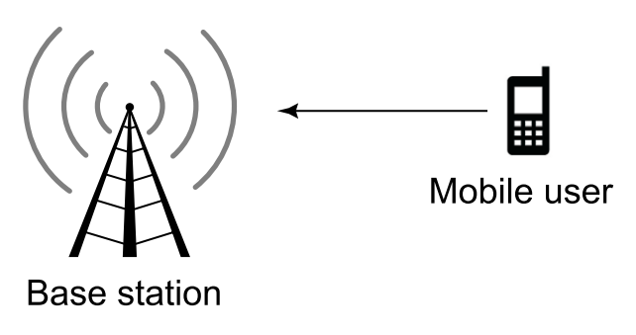
Figure: Doppler fading due to user mobility

Doppler Shift Computation
Consider the scenario shown pictorially in following figure, where the mobile station is moving with a velocity v at an angle θ with the line joining the mobile and base station. Let the carrier frequency be fc. The Doppler shift for this scenario is given as
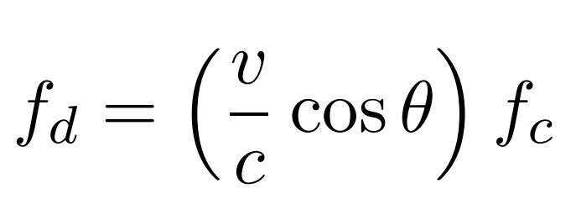
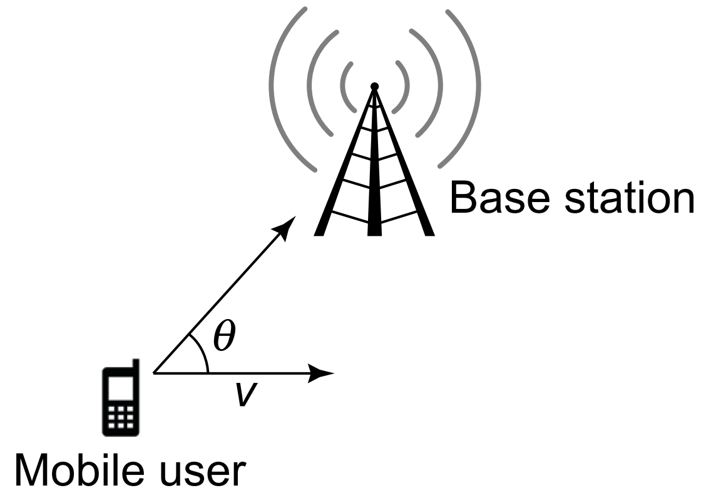
Figure: Doppler scenario
where c = 3 × 10⁸ m/s is the velocity of light, i.e., velocity of an electromagnetic wave in free space. It can be clearly seen that the Doppler shift increases with the velocity v. Moreover, it depends critically on the angle θ between the direction of motion and the line joining the transmitter and receiver. For instance, the Doppler shift is maximum when θ = 0, π, i.e., when the relative motion is along the line joining the transmitter and receiver. However, when θ = π/2, i.e., the motion is perpendicular to the receive direction, the Doppler shift is zero. Also, the Doppler shift is positive in the sense that the perceived frequency is higher if 0 ≤ θ ≤ π/2, in which case cos θ > 0. On the other hand, it is negative, leading to a lower perceived frequency that the transmit frequency is π/2 ≤ θ ≤ π.

 | Sinhgad Technical Education Society’s  RMD Sinhgad School of Engineering, Warje, Pune.  Department of E&TC Engineering | Expt.No.  7
Title | Doppler Shift
 | Student Worksheet

Problem Statement
Consider a vehicle moving at 60 miles per hour at an angle of θ = 30◦ with the line joining the base station. Compute the Doppler shift of the received signal at a carrier frequency of $f_{c}$ = 1850 MHz.

Formula
$$f_{d}=\left(\frac{v}{c}\cos{θ}\right)f_{c}$$
$f_{d}$ is the frequency shift in hertz, $v$ is the velocity of the target in meters/second, $λ=f_{c}/c$ is the wavelength in meters, $θ$ is the angle defined by the direction of target travel and the radar line of sight to the target.

Calculations
To begin with, we convert the velocity v from units of miles per hour to the standard metres per second. Noting that a mile is equal to 1.61 km, the required velocity in meters per second can be derived as
$$60 mph = 60 × 1.61 kmph = 60 × 1.61 ×\frac{5}{18} m/s = 26.8 m/s$$
Employing the expression shown above, the Doppler shift $f_{d}$ can be computed as
$$f_{d} =\frac{26.8}{3 × {10}^{8}} ×\cos{{30}^{0}}× 1850 × 106 = 143 Hz$$
Thus, the Doppler shift is $f_{d}$ = 143 Hz. Further, since the mobile user is moving towards the base station, the Doppler shift is positive, i.e., the perceived frequency $f_{r}$ is higher compared to the carrier frequency $f_{c}$ and is given as $f_{r}=f_{c}+f_{d}=1850 MHz + 143 Hz$.

Conclusion
In a mobile communication system, signals which are transmitted from mobile stations moving relative to a base station are subject to a Doppler effect. Here theoretical analysis and calculation of transmitter motion influence on received signal is conducted.

Review Questions
- How does Doppler shift affect mobile radio communication?
- What is Doppler shift in mobile communication?
- How do you mitigate the Doppler effect?
- What is fading and its types?
- What are the fading effects due to Doppler spread?
 | Sinhgad Technical Education Society’s  RMD Sinhgad School of Engineering, Warje, Pune.  Department of E&TC Engineering | Expt. No.  7
Title | Doppler Shift
Name
Roll No.

Program
- clc;
- clear all;
- speed = input('Enter the moving vehicle speed in miles per hour: ');
- theta = input ('Enter the angle of vehicle with the line joining the base station: ');
- carrier = input ('frequency over which Doppler shift is to be observed (in Hz): ');
- fprintf('1. mobile user is moving towards the base station \n2. mobile user is moving away from the base station\n');
- movement = input('Enter appropriate scenario: ');
- speed_m = speed * 1.61 * 5 / 18;
- speed_m
- fd = speed_m * cosd(theta) * carrier / (3 * 10^8) ;

- fprintf('The Doppler shift is fd = %d.\n', fd);

- switch movement
- case 1
- fprintf ('Since the mobile user is moving towards the base station, the Doppler shift is positive, i.e., the perceived frequency fr = %dHz + %dHz\n', carrier, fd);
- case 2
- fprintf ('Since the mobile user is moving away the base station, the Doppler shift is positive, i.e., the perceived frequency fr = %dHz - %dHz\n', carrier, fd);
- end

Output
Enter the moving vehicle speed in miles per hour: 60
Enter the angle of vehicle with the line joining the base station: 30
frequency over which Doppler shift is to be observed (in Hz): 1850000000
1. mobile user is moving towards the base station
2. mobile user is moving away from the base station
Enter appropriate scenario: 1
speed_m = 26.833
The Doppler shift is fd = 143.303.
Since the mobile user is moving towards the base station, the Doppler shift is positive, i.e.,
the perceived frequency fr = 1850000000Hz + 143.303Hz
>>

